**Install R**

The R programming language is not natively installed on your computer. In order to use R and by extension RStudio, we will need to install the base language from CRAN, the organization that oversees R.

1. Start by navigating your browser to CRAN, <https://cran.r-project.org/>. You will see the following screen...
   1. 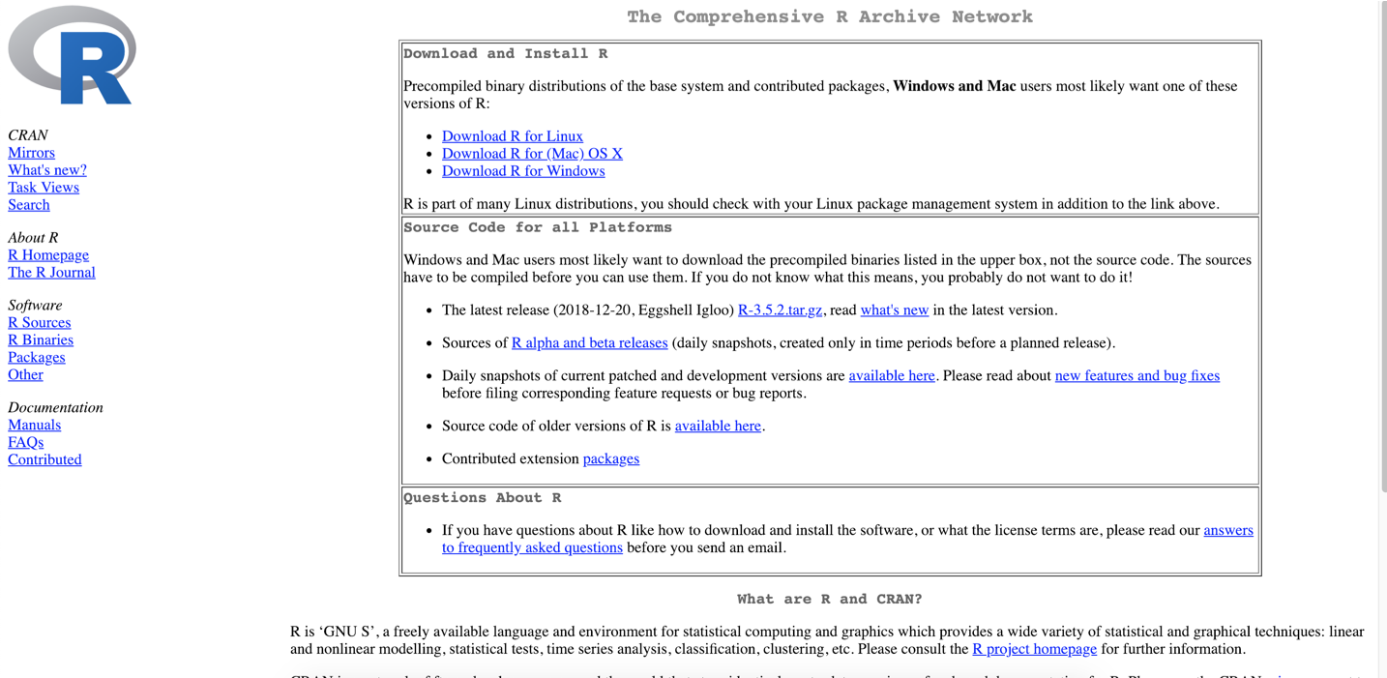
2. Under **Download and Install R**, select the proper operating system which will take you to a download page specific to your OS. **Please note installation steps for Windows and Mac OS are slightly different.**
   1. **Mac OS**
      1. Upon clicking **Download R for (Mac) OS X**, you will be brought to the following screen...

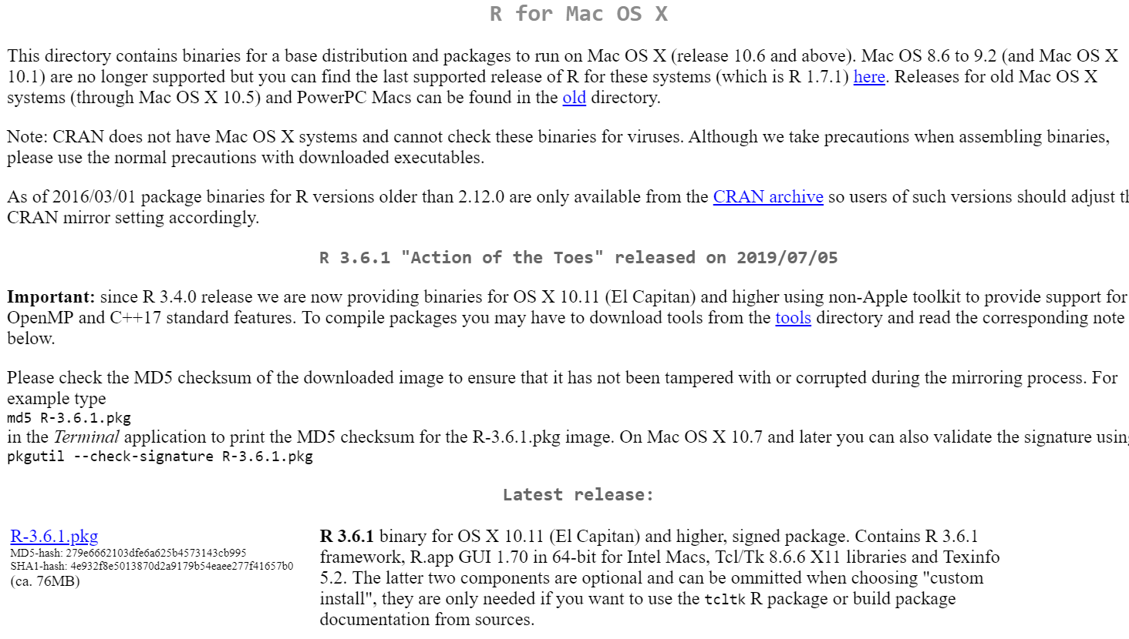

* + 1. Under **Latest Release**, click **R-3.6.1.pkg** to begin the download.
    2. Once downloaded, double the click the package to run the installation.
    3. Follow the screens on the installation screens until R install is completed.
    4. You now have R!
  1. **Windows**
     1. Upon clicking **Download R for Windows**, you will be brought to the following screen...
     2. 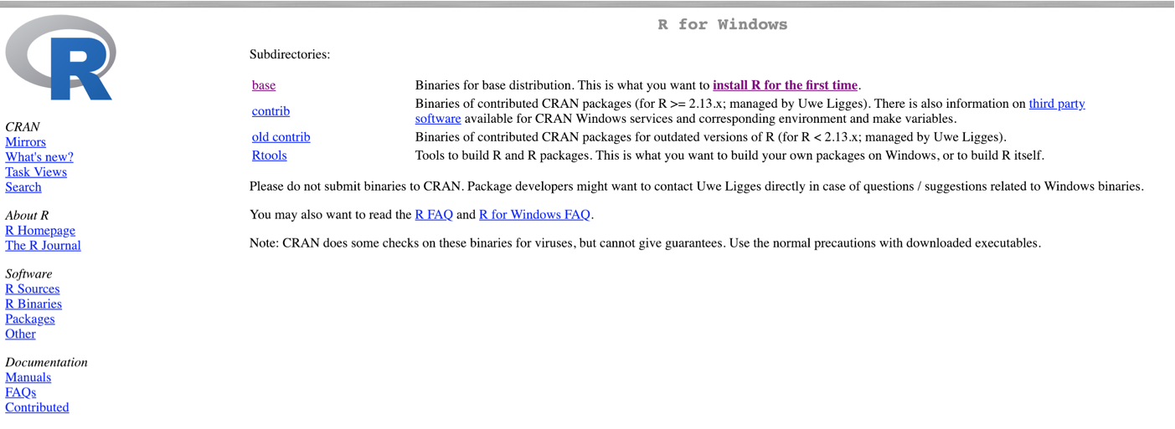
     3. Under Subdirectories, choose **base** which is the page we will need to download R for the first time.
     4. Under **R-3.6.1 for Windows (32/64 Bit)**, click **Download R 3.6.1 for Windows**.

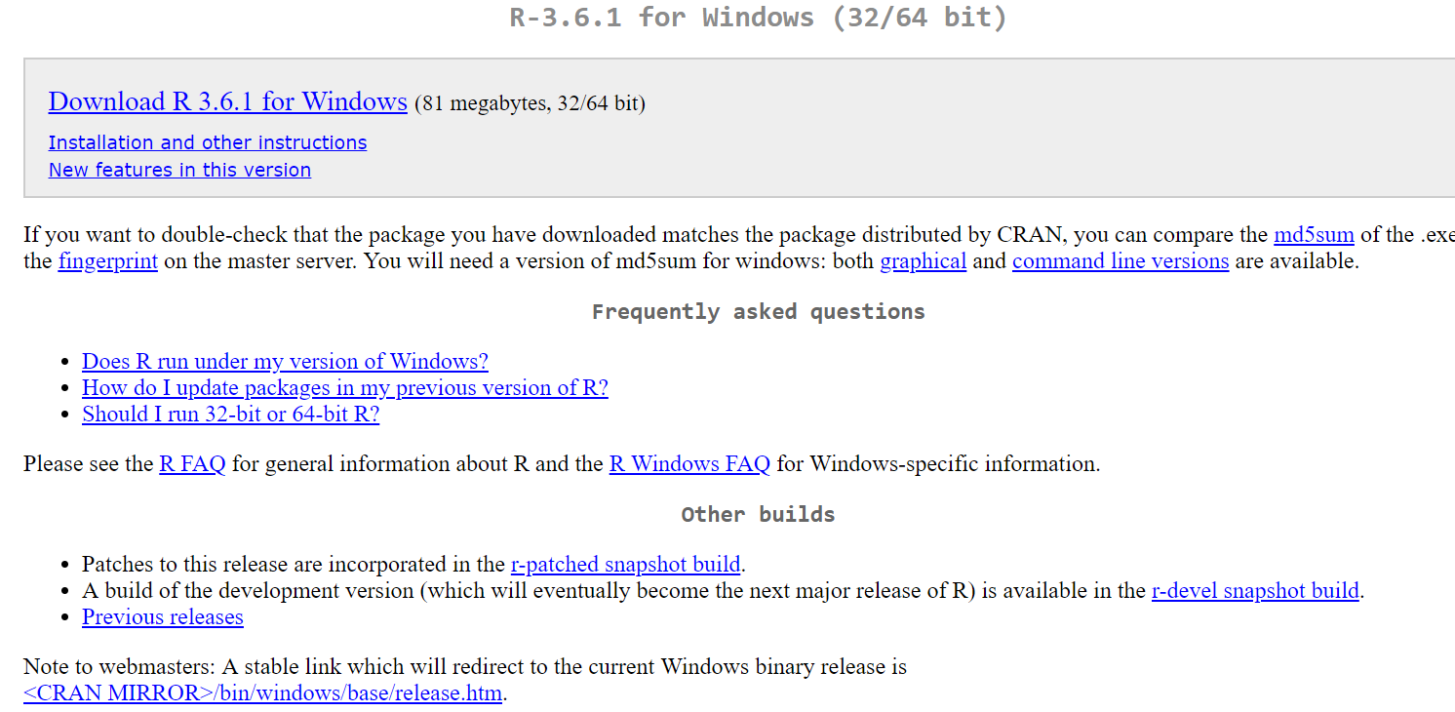

* + 1. Once downloaded, run R-3.6.1-win.exe to run the installation.
    2. You now have R!

**Install RStudio**

1. Start by navigating your browser to RStudio Downloads, <https://www.rstudio.com/products/rstudio/download/>. You will see the following screen…
   1. 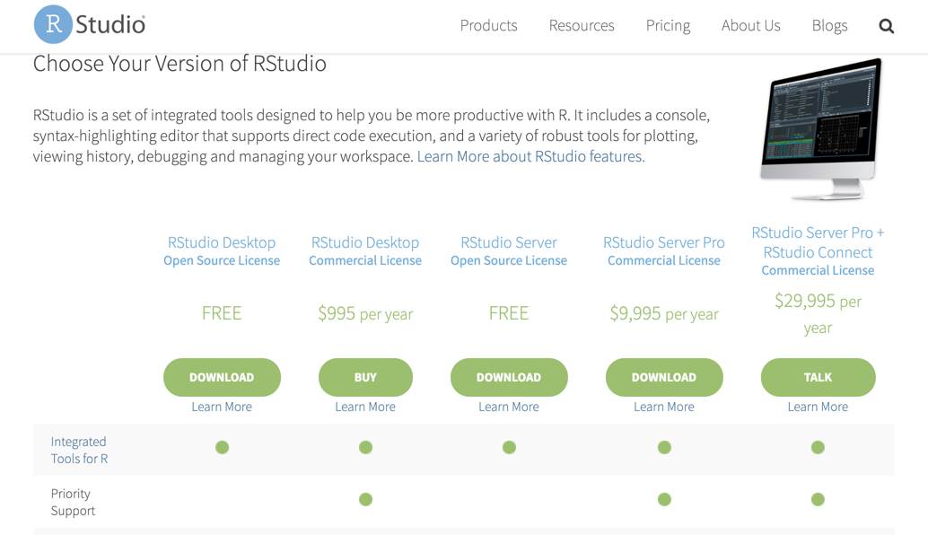
2. Under Choose Your Version of RStudio, choose RStudio Desktop - **Open Source License**.
3. The download button will drop you down the page to select the appropriate version for your operating system.

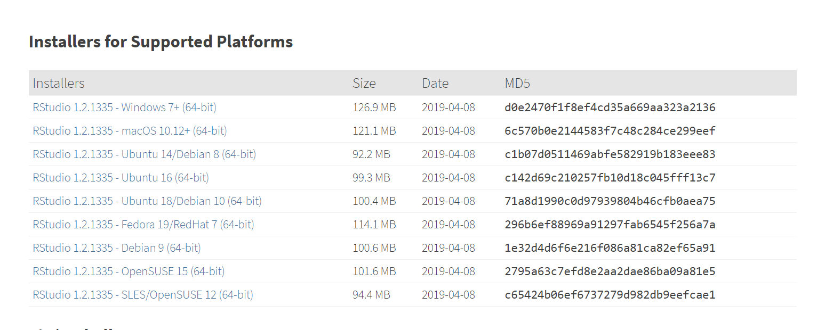

1. Once downloaded, run the installation file and perform the standard installation.
2. To confirm R & RStudio are installed, launch RStudio and you should see the following screen (your initial view may be slightly different).

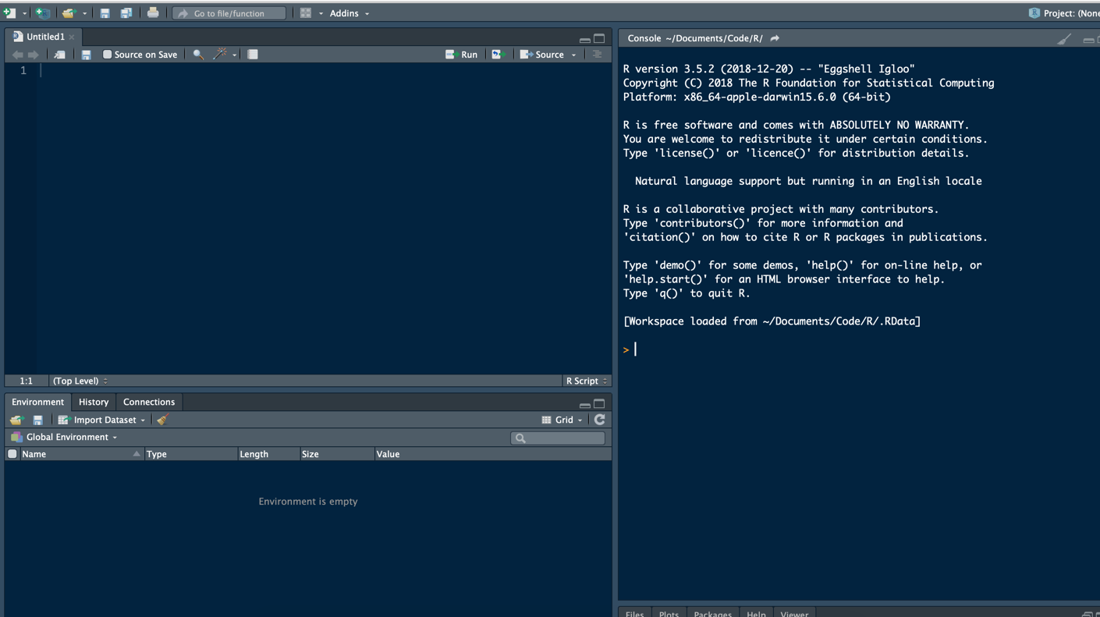

1. You now have RStudio!